Major Events Leading to Civil War
Missouri Compromise 1820-  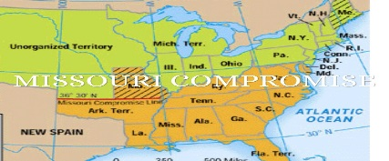 | Significance:
Compromise of 1850-  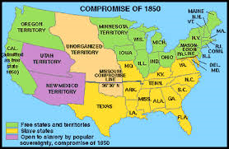 | Significance:
Kansas-Nebraska Act-  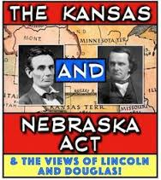 | Significance:
Dred-Scott Case & Decision- | Significance:
Election of 1860-  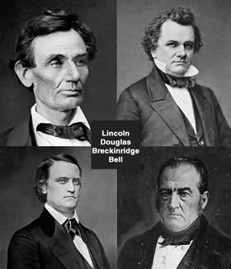 | Significance:

