Famous Georgians of the American Revolution

Elijah Clarke | Austin Dabney | Nancy Hart
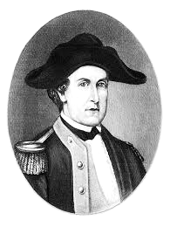 | 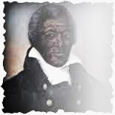 | 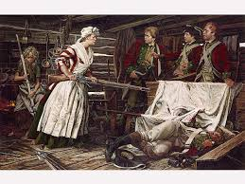

Extra Notes:

