Georgia’s Land Policies
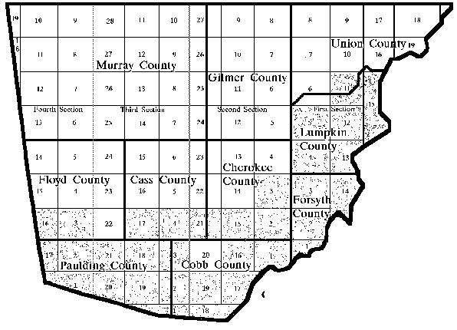
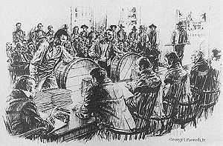
SS8H5 Evaluate the impact of land policies pursued by Georgia; include the headright system, land lotteries, and the Yazoo Land Fraud.
Headright System | Yazoo Land Fraud | Land Lotteries

