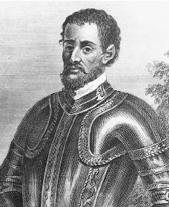
Hernando DeSoto & Spanish Missions
Pros & Cons: Hernando DeSoto (Spanish) Exploration in South East America
Pros | Cons
Hernando DeSoto (additional notes from videos & text):

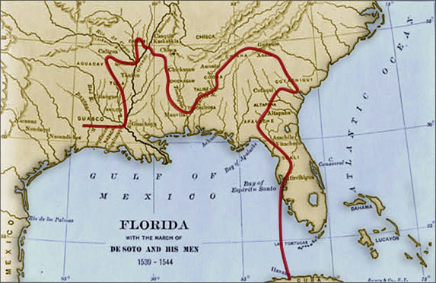
Where were they located? |  | Why were they established?
Spanish Missions:
