Jim Crow Laws | Plessy vs. Ferguson
- What were Jim Crow Laws?  - What did these laws segregate?  - Other Information (i.e. business effects):  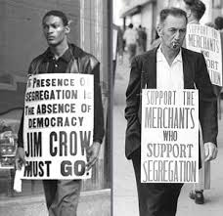 | - Who, When, and Where:  - What (Brief Description):  - U.S. Supreme Court Ruling:  