European Explorations-Americas
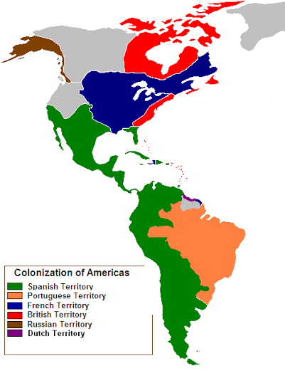
Reasons for European Explorations of North America:
Country | Settlement Regions (North America) | Reasons  (Resources) | Famous Explorers

