Technological Advancements
SS8H5: Explain how technological developments, including the cotton gin and railroads, had an impact on Georgia’s growth.
Cotton Gin | Railroads
 | 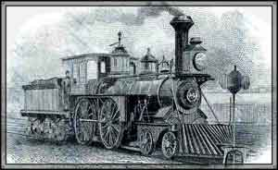
Who:  What:  Where:  When:  Why:  How: | Who:  What:  Where:  When:  Why:  How:

