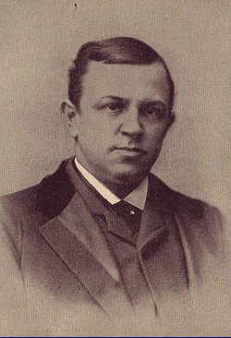  Henry Grady | List Five Facts about Henry Grady
The New South (Progressive Era)
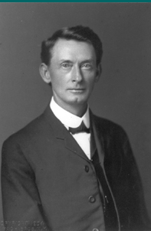  Tom Watson | List Five Facts about Tom Watson or the Populists  1.  2.  3.  4.  5.
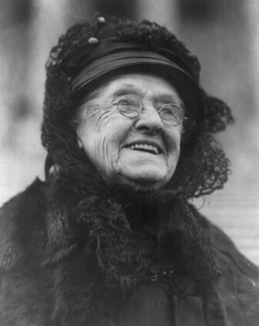  Rebecca Latimer Felton | Summarize the life of Rebecca Latimer Felton
International Cotton States Exposition | Atlanta Riot of 1906

