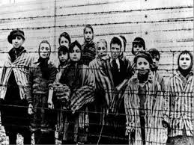

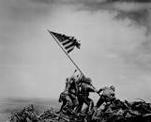

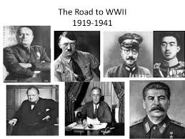

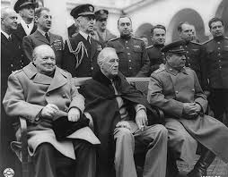

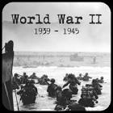

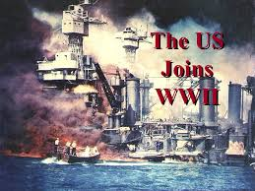

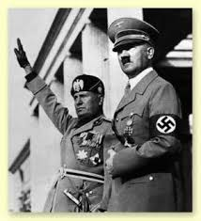

**Alliances of World War II**

**Allied Powers (Nation & Leader):**

**Axis Powers (Nation & Leader):**

**Causes of World War II**

**Imperialism & Nationalism:**

Germany-

Japan-

Italy-

**Famous Generals &**

**Georgia’s Contributions to World War II**

**Pacific & European Fronts (Theatres)**

**Allied Strategy in Pacific-**

**Allied Strategy in Europe-**

**Key Battles**

**U.S.A**

**America’s Involvement-**

**Pre-War Preparations-**

